**Circuit Diagram**

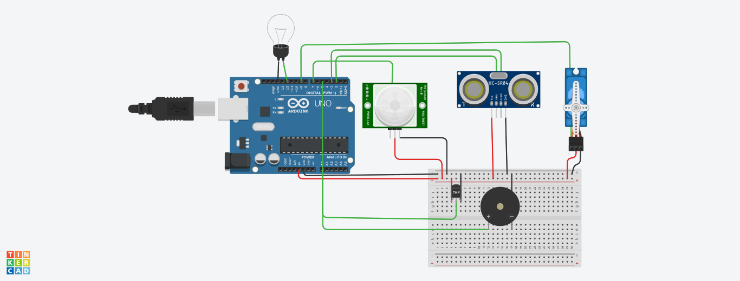

**Source Code**

#include<Servo.h>

int t=2;

int e=3;

int led=12;

int sensor=7;

int buz=5;

int state=LOW;

int val=0;

Servo s;

void setup()

{

pinMode(led, OUTPUT);

pinMode(sensor,INPUT);

pinMode(t,OUTPUT);

pinMode(e,INPUT);

pinMode(buz,OUTPUT);

s.attach(9);

Serial.begin(9600);

}

void loop()

{

val=digitalRead(sensor);

if(val==HIGH)

{

digitalWrite(led,HIGH);

delay(500);

}

digitalWrite(t,0);

digitalWrite(t,1);

delayMicroseconds(10);

digitalWrite(t,0);

float dur =pulseIn(e,HIGH);

float dis=(dur*0.0343)/2;

Serial.print(dis);

if(dis<100)

s.write(180);

else

s.write(0);

double T=analogRead(A0);

double te=(((T/1024)*5)-0.5)*100;

if(te>70)

tone(5,100);

else

noTone(0);

}